# Gradient Generator

**Step 1: Open** [**https://tipsytip.com/gradient-tool**](https://tipsytip.com/gradient-tool) **on Google Chrome**

**Step: 2**

* **Right click on chrome and click on inspect**

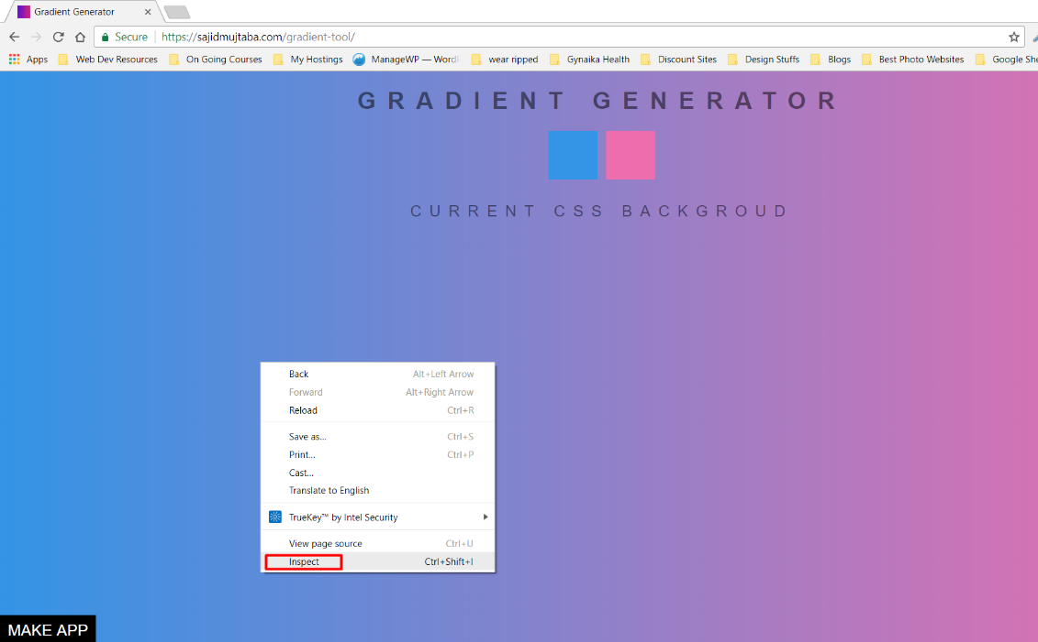

* **Click on Application Tab**

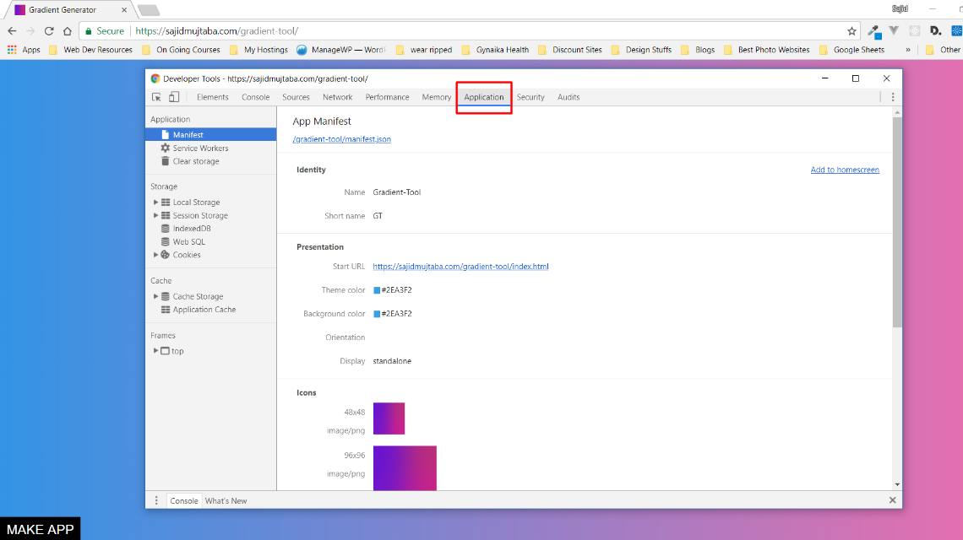

* **Click on Add to homescreen**

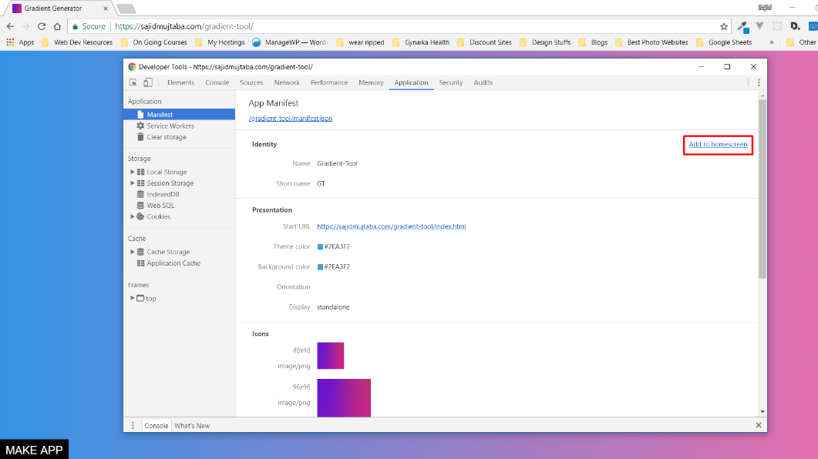

* **Click on Add button that popped up on Google Chrome**

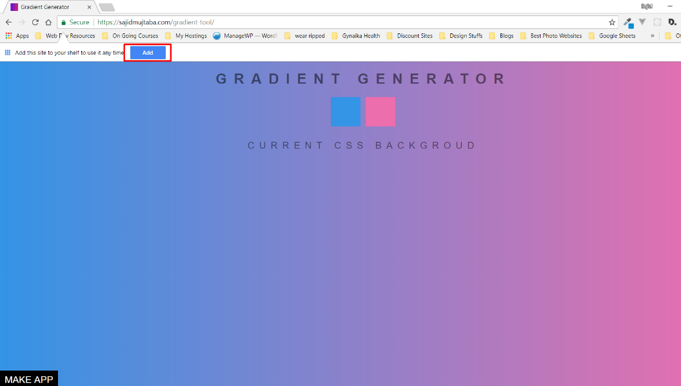

* **Click on Add button and make sure Open as window checkbox is ticked**

